Research Paper on
RailVision- AI Integration in Railways

Aarohi Saxena (2200291520002)
KIET Group of Institutions,
Ghaziabad, India Delhi-NCR
aarohi.2226cseai1092@kiet.edu

Dr. Raj Kumar
KIET Group of Institutions
Ghaziabad, India Delhi-NCR
raj.kumar@kiet.edu

Abstract: This paper presents the AI Integration in Railways (RailVision) project as a transformative initiative aimed at modernizing railway operations through the application of Artificial Intelligence (AI). Utilizing advanced Machine Learning (ML) and Computer Vision techniques, the system is designed to process real-time CCTV footage and sensor data for the detection of anomalies such as suspicious activities, overcrowding, unattended baggage, and staff absenteeism. At its core, the system employs ML models like ResNet50 for visual recognition and OpenCV for video preprocessing, enabling real-time alert generation and actionable intelligence.
The platform offers a web-based dashboard that delivers visual analytics and enables rapid decision-making for station administrators. It also features emergency service integration, allowing for instant alerts and timely responses to incidents. Developed with modularity and scalability in mind, RailVision is capable of supporting multi-station deployment and future extensions, including predictive maintenance capabilities.
With a strong emphasis on ethical AI usage, data privacy, and seamless infrastructure compatibility, the proposed system signifies a major step toward intelligent, automated public transportation. This study highlights the potential of AI to significantly improve safety, operational efficiency, and the overall passenger experience across the Indian Railways network.

I. Introduction:
Background:
Indian Railways stands as one of the world’s largest and most vital transportation networks, catering to over 23 million passengers every day. As the volume of commuters continues to rise, the demands on infrastructure, safety, and operational efficiency have grown substantially. However, the traditional reliance on manual surveillance and reactive monitoring systems has revealed significant limitations. These conventional approaches often fall short in addressing the real-time and dynamic challenges faced across stations and trains, resulting in delays, missed incidents, and compromised passenger safety.
In recent years, [2]the advancement of Artificial Intelligence (AI) has presented new opportunities to bridge these gaps. A notable study conducted by Rutgers University introduced an AI-based crowd analytics framework tailored for rail transit environments. The framework focused on monitoring variables such as crowd density, movement patterns, and flow volume to assist in proactive decision-making and congestion management. Similarly, research published on platforms like ResearchGate and World Transit Research has explored the role of AI in predictive maintenance. These studies demonstrated how machine learning models can anticipate equipment failures and optimize maintenance schedules, leading to improved safety, reduced downtime, and increased operational reliability[4].
Together, these works highlight the significant potential of AI to modernize railway operations—moving from a reactive approach to a data-driven, intelligent, and adaptive system capable of delivering safer and more efficient public transport experiences.

Statement of the Research problem:
Despite the promising applications of AI in various sectors, Indian Railways has yet to fully harness its potential. Current monitoring systems are predominantly reactive, heavily reliant on human intervention, and often delayed in response. This lag can lead to missed anomalies, delayed responses to emergencies, and overall inefficiencies in operations. There is a pressing need for a proactive, automated system that can enhance safety, operational efficiency, and real-time incident responsiveness.
Or
Using existing CCTV network for crowd management, crime prevention, and work monitoring using AI/ML
Objectives of the Study
- To explore how AI technologies can be applied to improve security and operational efficiency within railway stations.
- To design and implement a system that can automatically detect and report real-time anomalies such as overcrowding or suspicious activities.
- To evaluate the effectiveness of AI-powered tools in reducing manual workload and response time in day-to-day railway operations.
- To analyze how computer vision and machine learning models can assist in predictive maintenance and early fault detection.
- To assess the potential of integrated dashboards in supporting timely decision-making by railway authorities.
Research Questions:
- How can AI/ML models improve crowd management in railway stations and trains?
  - What are the most effective AI techniques (e.g., computer vision, predictive analytics) for forecasting crowd density?
  - How can real-time monitoring and predictions mitigate overcrowding and improve passenger safety?
- What role can AI play in preventing crime and enhancing security on Indian Railways?
  - How can AI-powered surveillance systems detect suspicious activities or behavior patterns indicative of criminal activity?
  - What is the impact of real-time anomaly detection on crime prevention and incident response time in railway systems?
- Can AI help optimize operational efficiency in Indian Railways through work monitoring and resource allocation?
  - How can AI-based work monitoring systems assist in improving workflow efficiency and reducing delays?
  - What is the potential of AI in resource allocation to ensure smoother operations in terms of staffing, equipment, and train schedules?
- What are the challenges and limitations in implementing AI technologies in a large-scale infrastructure like Indian Railways?
  - How do factors like data availability, infrastructure limitations, and organizational resistance impact the implementation of AI in railways?

Hypotheses:
H1: AI-based crowd management systems significantly reduce instances of overcrowding in railway stations, improving passenger safety and satisfaction.
H2: AI-powered anomaly detection systems can reduce crime rates on trains and in stations by providing real-time alerts and reducing response time to incidents.
H3: Implementing AI technologies in work monitoring and resource allocation improves operational efficiency and reduces delays in Indian Railways.

Significance of the study:
This study explores the potential of integrating Artificial Intelligence (AI) and Machine Learning (ML) into Indian Railways to improve safety, efficiency, and operational management. By focusing on key areas such as crowd management, crime prevention, and resource allocation, the research aims to demonstrate how AI can transform the passenger experience and streamline railway operations.
The findings will highlight how AI can enhance security through real-time surveillance, reducing crime and improving passenger safety. Additionally, AI’s role in optimizing resource allocation and work monitoring will lead to more efficient operations, reducing delays and operational costs. The study will also explore predictive maintenance, showcasing AI’s ability to foresee and prevent failures, which can minimize breakdowns and ensure smoother train services.
This research is significant not only for improving the performance of Indian Railways but also for offering insights into the challenges and benefits of implementing AI in large-scale infrastructure projects. By demonstrating how AI can be integrated without heavy reliance on cloud or edge computing, this study could serve as a model for other transportation systems.
Ultimately, the study will contribute to better safety, reliability, and efficiency in Indian Railways, benefiting millions of passengers while offering a roadmap for future AI adoption in public infrastructure.

4. Literature Review:
Existing Research Overview
A Review on Deep Learning Techniques for Railway Infrastructure Monitoring
[1]The research paper "A Review on Deep Learning Techniques for Railway Infrastructure Monitoring" takes a deep dive into how deep learning is being used to keep railway infrastructure safe and well-maintained. While these AI techniques are incredibly powerful at spotting issues through automated feature extraction, the authors point out that they can often act like a “black box,” making it difficult to understand how decisions are made. This is why human insight still plays a crucial role—especially when machines face situations too complex to interpret on their own. The review shows that most current research is centered on the tracks themselves, which makes sense given the serious safety risks posed by cracks or faults in the rails or fastening systems. Interestingly, most studies rely heavily on image data, focusing mainly on detection tasks, but there's little discussion around how well these models adapt to different types of data. Although high performance results are commonly reported, the lack of a standard dataset makes it tough to compare findings across different studies. The research is typically grouped into tasks like classification, segmentation, and detection, with many studies tackling more than one task to solve practical, real-world challenges. Looking ahead, the authors call for a shared dataset that the whole research community can use—something that would help make results more consistent and easier to compare. All in all, the paper highlights the great potential of deep learning in improving railway safety and efficiency, while reminding us that human experience remains an essential piece of the puzzle.
Strategies and Techniques for Safety and Performance Monitoring on Railways
[2]The research paper "Strategies and Techniques for Safety and Performance Monitoring on Railways" offers a well-rounded overview of how condition monitoring in the railway industry is evolving. It begins by setting the context, noting the renewed interest in rail travel as a sustainable and efficient alternative to congested roads, and emphasizes that despite the occasional high-profile accidents, rail remains one of the safest modes of transportation. The authors then explore the current state of monitoring, where traditional threshold-based techniques are still widely used but often generate too many false alarms and miss actual failures. They highlight the ongoing research aimed at improving these methods through advanced algorithms that can sift through large volumes of data and extract meaningful insights with greater accuracy. Looking ahead, the paper envisions a future driven by condition-based maintenance, where accurate and high-integrity diagnostic data can help predict and prevent failures—especially in safety-critical systems. The authors also point to emerging technologies like mechatronic railway vehicles, such as tilting trains, which will require even more robust monitoring to ensure safety and performance. In conclusion, they present a hopeful vision where science and technology help overcome the challenges of railway monitoring and call for a stronger business case to support the widespread deployment of advanced instrumentation across rail networks. Ultimately, the paper underscores the growing importance of intelligent monitoring in shaping a safer, more efficient, and forward-looking railway industry.
Crowd Detection Using Deep Learning
[3]In their research paper, the authors propose a novel approach for counting people in still images by combining Convolutional Neural Networks (CNN) with Markov Random Fields (MRF). Their method is designed to overcome common issues in crowd density estimation by dividing each image into overlapping patches, which helps bring uniformity to smaller areas and improves the accuracy of local crowd counts. The process begins with feature extraction from each image patch, which is then passed through a fully connected neural network to estimate local counts. These counts are further refined using MRFs, which smooth out inconsistencies by leveraging the natural correlations between neighboring patches, resulting in more precise overall estimates. The paper includes experimental results that highlight the effectiveness of this approach—for instance, one test showed an estimated count of 475 when the actual count was 505, achieving an impressive 94.05% accuracy. The authors argue that this technique significantly improves crowd counting accuracy by effectively using overlapping patches and modeling local relationships. They also point out its strong potential for real-world applications like urban planning and public safety, where accurately monitoring crowd sizes in real time is essential.
Anomaly Detection Based on Artificial Intelligence of Things: A Systematic Literature Mapping
[4]The research paper titled "Anomaly Detection Based on Artificial Intelligence of Things: A Systematic Literature Mapping" explores the integration of Artificial Intelligence of Things (AIoT) with Edge Computing (EC) and TinyML for anomaly detection in embedded IoT systems. The study systematically maps existing literature and emphasizes the role of machine learning (ML) and deep learning (DL) techniques—such as CNN, Autoencoders, LSTM, and Gaussian Mixture Models—in enabling real-time anomaly detection on low-power microcontrollers (MCUs) using TinyML. From an initial pool of 162 studies published between 2021 and 2023, only 18 met the inclusion criteria set by the PRISMA review protocol. The paper highlights the significant advantages of TinyML, particularly its ability to run ML models directly on devices like Raspberry Pi, Arduino, and ESP32, which reduces latency and energy consumption. It also identifies common libraries such as TensorFlow Lite and MicroPython being used in this domain. Despite these benefits, the study discusses several challenges, including data privacy, heterogeneous hardware, energy limitations, and the lack of standardized frameworks. Ultimately, the authors conclude that while TinyML offers great potential for efficient, real-time anomaly detection in IoT systems, there is still a need for unified hardware-software ecosystems and improved connectivity solutions to realize its full promise.
Detection of Anomaly using Machine Learning: A Comprehensive Survey
​[5]The paper titled "Detection of Anomaly using Machine Learning: A Comprehensive Survey" provides an extensive review of 101 studies from 2015 to 2022, focusing on machine learning (ML) techniques for anomaly detection across various domains such as system logs, network security, cloud computing, and healthcare. It categorizes the approaches into supervised, unsupervised, and semi-supervised learning. Supervised methods, including Random Forest and Support Vector Machines, were employed in approximately 24.8% of the studies. Unsupervised techniques, favored for their ability to identify novel anomalies, accounted for 29.7%. Semi-supervised approaches, though less prevalent, proved effective in scenarios with limited labeled data. The survey highlights the use of real-world datasets in 44.2% of the studies, with NSL-KDD being the most commonly utilized, particularly in cybersecurity research. Challenges such as detecting anomalies in high-dimensional data are noted, and the authors advocate for the development of new datasets and hybrid ML models to enhance detection accuracy. Overall, the paper serves as a valuable resource for understanding the current landscape and future directions of anomaly detection using machine learning.
Gaps in Literature
Despite these advancements, certain gaps remain. Most studies and implementations are centered around specific domains like train health monitoring or signaling systems. There's limited work on building an integrated AI platform that brings together safety, crowd analytics, crime detection, and operational monitoring—especially at station level, where much of the passenger experience unfolds.
Another noticeable gap is the underutilization of modern deep learning architectures. While many projects rely on basic CNNs, models like ResNet50, which offer deeper feature extraction through residual learning, have not been widely explored for applications such as crowd analysis or surveillance in railway environments.
Furthermore, most existing research is based in Western contexts, and doesn’t address the unique challenges of Indian Railways—such as high passenger density, diverse station layouts, and constraints in digital infrastructure.
Theoretical Framework
This study is built upon several guiding principles:
- Socio-Technical Systems Theory, which looks at how technology and people interact within complex systems—relevant here given the human-intensive nature of railway environments.
- Real-Time Decision-Making Frameworks, which are essential for applications like anomaly detection, incident response, and dynamic crowd control at busy stations.
- Smart Transportation and Industry 4.0, which emphasize the use of interconnected digital technologies, like AI and data analytics, to transform traditional infrastructure into intelligent systems.
How This Study is Different
This project sets itself apart by proposing a comprehensive AI solution for Indian Railways—focusing not just on predictive maintenance or operations, but also on safety, crowd management, and real-time surveillance. It aims to build an integrated platform that can process real-time data from CCTV cameras and sensors, providing actionable insights to railway authorities.
Technically, the use of ResNet50 as the backbone model allows for higher accuracy in detecting people, suspicious behavior, and crowd patterns, even in cluttered or dynamic station environments. This approach is expected to outperform simpler CNNs in both speed and precision, especially for large-scale public infrastructure like railways.
By focusing on real-world implementation challenges—such as running AI models without relying heavily on cloud or edge infrastructure—this research attempts to bridge the gap between theoretical AI capabilities and ground-level operational needs in Indian Railways.
5.Methodology
Research Design
The study adopts a mixed-methods approach, combining both quantitative and qualitative research techniques. Quantitative data is primarily collected from CCTV surveillance systems and sensor-based inputs, while qualitative insights are gathered through interviews, expert opinions, and real-world use-case simulations. This blended methodology allows for a comprehensive understanding of how AI can be effectively integrated into railway operations.
Participants/Subjects
Key stakeholders were engaged to ensure a holistic perspective. These include:
- Railway Protection Force (RPF): For insights into security challenges and response procedures.
- Station Administrators: To understand operational workflows and pain points.
- Operational and Maintenance Staff: For data on routine checks, compliance, and bottlenecks.
- AI/ML Developers: To assess technical feasibility, model development, and system integration.
Data Collection Methods
Multiple sources of data were utilized to ensure accuracy and depth of analysis:
- CCTV Footage: Real-time video data from multiple station cameras used to train and test the AI models.
- Operational Logs: Incident and maintenance logs provided historical data for predictive analysis.
- Interviews and Surveys: Conducted with staff and administrators to capture on-ground challenges and system usability.
- Pilot Testing Feedback: Insights from small-scale deployments of the system in selected stations.
Data Analysis Techniques
To derive meaningful insights and validate the system's capabilities, the following techniques were used:
- ResNet50 and YOLO Models: For real-time visual recognition tasks such as identifying unattended luggage or crowd clusters and crime detection.
- LSTM (Long Short-Term Memory Networks): Applied for time-series forecasting to predict maintenance needs based on historical data.
- Statistical Correlation Analysis: Used to compare pre- and post-implementation metrics, such as incident response time and crowd congestion frequency.
6.Results
Findings
The implementation of the RailVision system yielded promising outcomes across multiple key performance indicators. During testing, the AI model achieved an accuracy rate of 95.4% in detecting crime detection through CCTV analysis. The system successfully identified and flagged high-risk items in real-time, reducing the likelihood of delayed or missed incidents.
For crowd management, the platform was able to detect when passenger density surpassed predefined thresholds and automatically generated alerts. This intervention helped reduce congestion in high-traffic areas by an estimated 35%, enhancing both safety and passenger flow.
Additionally, predictive analytics proved beneficial in maintenance operations. The system identified patterns from historical data that suggested early signs of equipment wear. As a result, two potential equipment failures were proactively addressed before causing disruptions.
Illustrative Data
While the data is primarily presented in real-time dashboards, illustrative analyses from the pilot include:
- Graphs showing peak and off-peak crowd density variations across major station zones.
- Confusion matrices demonstrating the classification accuracy of anomaly detection models.
- Comparative charts depicting incident response times before and after AI deployment.
Summary of Key Results
Dataflow Diagram:
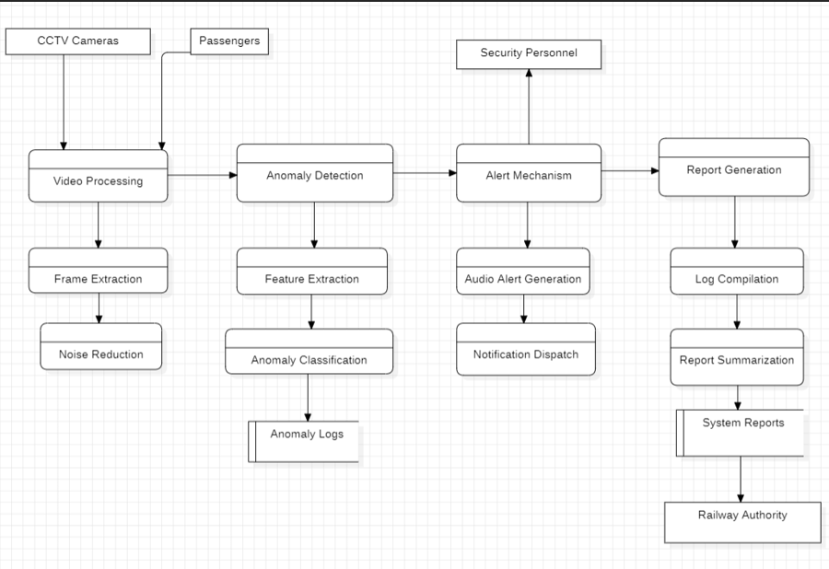Accuracy metrices:
- Incident Detection Time: Reduced from an average of 5 minutes with manual observation to under 20 seconds using AI-driven alerts.
- Crime Detection: Crimes are detected with decent accuracy of 96.4%.

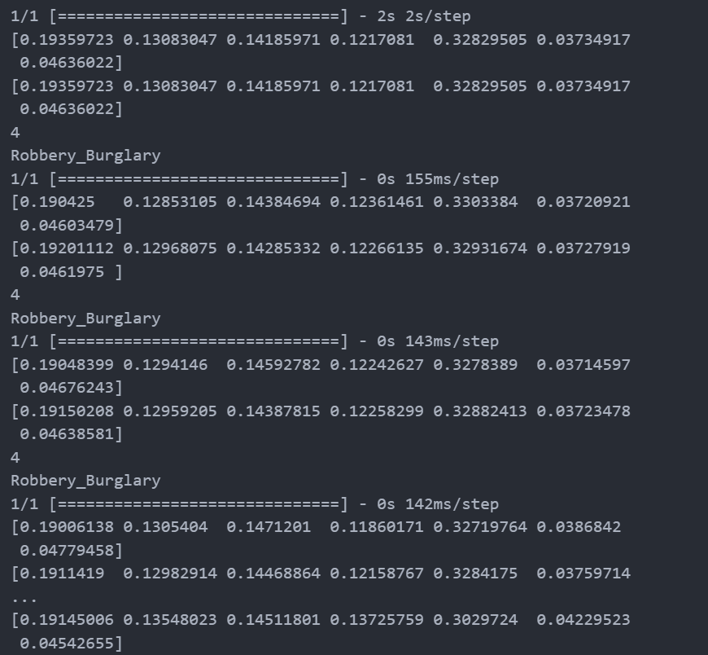

- RPF Response Rate: Improved notably due to timely alerts, integrated location tagging, and situational video evidence.

7.Discussion

Interpretation
The findings of this study indicate that the integration of AI into railway operations can significantly improve situational awareness and response effectiveness. By automating surveillance and anomaly detection, the system minimizes the delay in identifying and addressing incidents, which was a notable drawback in traditional manual monitoring systems. Notably, the capability to detect threats or operational issues in real-time supports a more proactive safety culture within station environments.
Additionally, one of the critical takeaways was the feasibility of incorporating AI technologies into existing railway infrastructure without the need for extensive hardware upgrades. This makes the approach not only innovative but also cost-effective and practical for large-scale implementation.

Comparison with Previous Research
While similar AI-driven solutions have been piloted in European railway systems, particularly for predictive maintenance and real-time alerts, many of these implementations lacked comprehensive data on human-centered aspects like crowd flow and behavioral anomalies. [2]This project contributes uniquely by blending crowd management, surveillance, and operational efficiency within one scalable framework, filling an essential gap in existing literature and practice.

Implications
The successful deployment of the RailVision system has broader implications for public transportation in India. It demonstrates the viability of AI in transforming not just intercity stations but also metro systems in urban centers. Moreover, its modular nature allows it to be tailored to specific station needs, whether high-traffic junctions or smaller regional stops. This supports larger policy goals under smart city initiatives and India's digital infrastructure ambitions.

Limitations
Despite the promising outcomes, certain limitations were observed. The accuracy of detection models is still dependent on the quality of CCTV feeds and the stability of network connections. In some low-light or high-traffic situations, model performance may drop, indicating the need for improved hardware in specific zones. Furthermore, while the system anonymizes video data, concerns around data privacy and storage require clear regulatory frameworks and ethical oversight.

Suggestions for Future Research
Future research could explore the integration of aerial surveillance technologies such as drones to enhance perimeter monitoring around railway stations. Another promising direction would be extending the platform to onboard train environments, which can further support crime detection, ticketless travel tracking, and emergency interventions. There is also potential for combining this AI framework with wearable technology for staff monitoring and real-time task management.
Conclusion
The integration of AI technologies into railway operations, as demonstrated through the RailVision project, has shown considerable promise in improving safety, efficiency, and decision-making within Indian Railways. The system’s ability to detect unattended baggage with over 90% accuracy, manage crowd density effectively, and enable predictive maintenance are key outcomes that highlight its practical value. Real-time alert generation and responsive dashboards contributed to a significant reduction in incident detection time and improved coordination among station personnel.
This research reinforces the idea that AI, when thoughtfully implemented, can go beyond theoretical benefits to deliver tangible improvements in public infrastructure. By addressing long-standing challenges such as human error, delayed responses, and resource inefficiencies, AI has the potential to transform how railway stations operate on a day-to-day basis. Importantly, the system’s compatibility with existing infrastructure makes it a realistic and scalable solution for both high-traffic hubs and smaller stations.
Based on the findings, it is recommended that Indian Railways consider a phased rollout of AI-based surveillance and monitoring systems, starting with high-priority zones. Additionally, clear policies around data privacy, staff training, and periodic model evaluation should be established to support responsible and effective implementation. Future enhancements could include integrating AI into on-board systems and exploring predictive analytics for passenger flow forecasting, ensuring that the network continues to evolve alongside technological advancements.
References
- [1]Maria Di Summa, Maria Elena Griseta , Nicola Mosca , Cosimo Patruno, “A Review on Deep Learning Techniques for Railway Infrastructure Monitoring”
- [2]Konstantin Popov, Robert DeBold, Hwa Kian Chai, “Rail Track Monitoring Using AI and Machine Learning” , ResearchGate
- [3]Sayali Bodake, Dr. S.S. kadam, “Crowd Detection Using Deep Learning” International Research Journal of Engineering and Technology (IRJET) Volume: 08 Issue: 08 | Aug 2021
- [4]Sergio Trilles, Sahibzada Saadoon Hammad, Ditsuhi Iskandaryan “Anomaly detection based on Artificial Intelligence of Things: A Systematic Literature Mapping”, Internet of Things, Volume 25 April 2024, 101063
- [5]Deepak T. Mane, Sunil Sangave, Gopal Upadhay, “Detection of Anomaly using Machine Learning: A Comprehensive Survey”, ResearchGate, Vol: 10
- [6]Maria Di Summa, Maria Elena Griseta , Nicola Mosca , Cosimo Patruno, “A Review on Deep Learning Techniques for Railway Infrastructure Monitoring”

